LES Deprecation – Testing Guideline

Feature Owner | Nithya
Spec Version | V1.0
Audience to Review | Diganta, Mukesh

Table of Contents
1 Introduction 2
2 Hybrid Tenant Setup (Rampup) 2
3 Test Plan 4
3.1 Test Scenarios for LES Recipient Management without WriteBack 4
3.2 Test Scenarios for LES Tenant Management without WriteBack 4
3.3 Test Scenarios for LES Recipient Management with WrietBack 4
3.4 Test Scenarios for LES Tenant Management with WrietBack 4
4 Testing Timeline 4
5 Steps to Report Bugs 4
6 Refernces 4
7 Change History 4

Acronyms

LES | Last Exchange Server
SOA | Source of Authority
Dir-Sync | Directory Sync [any User/Group/Contact that’s created in Onprem and synced to cloud is usually termed as dir-synced object in cloud, for eg: a remote mailbox created in Exchange server, can be termed as dirsynced mailbox in cloud]
EntraID | Erstwhile AAD or Azure Active Directory
EXO | Exchange Online
EAC | Exchange Admin Center []
SDF v2 | These are special Dogfood test tenants.

Introduction

In an Exchange Hybrid, recipient management of cloud mailboxes (User, Group and Contacts) is not allowed in Exchange Online. Customers need to use on-premises Exchange Server to edit these recipients in AD and sync the changes to cloud via Cloud Sync or Connect Sync. This leads to a situation where even though customer data like mailboxes reside in the cloud, they must rely on on-premises Exchange Server to manage their cloud mailboxes (by updating Exchange on-prem which updates AD which syncs to the cloud). The primary focus of this document is to provide detailed guidelines to test the cloud management of exchange attributes of dir-synced mailboxes (Exchange attribute level SOA transfer to cloud).
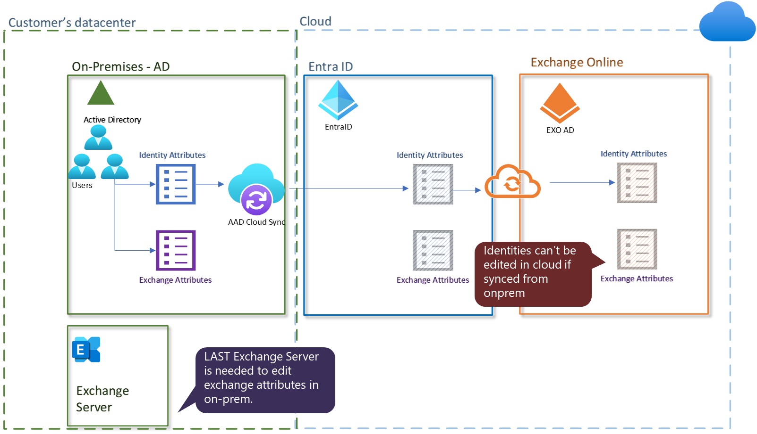
In addition to Exchange attribute SOA transfer, we will also discuss User and Group SOA transfer as well since there is a parallel initiative ongoing which is being driven by EntraID team. Before we dive deep, let’s understand what SOA transfer means at a high level.

Exchange attribute SOA transfer
Exchange attribute SOA transfer of dir-synced mailboxes (or remote mailboxes) to cloud allows customer to edit Exchange attributes of dir-synced mailboxes directly in cloud using EXO PowerShell or M365 EAC, while Identity attributes can be edited only in on-prem AD.
For example, if a user mailbox’s exchange attribute SOA is transferred to cloud, to edit user’s first name, last name etc., I must use on-premises AD, but to edit user mailboxes exchange attribute like hidefromaddresslist, I must use EXO PowerShell or M365 EAC.
A detailed list of Identity vs Exchange attributes is provided in this document.

User and Group SOA transfer
In User/Group SOA transfer, the entire object becomes a cloud-only object after SOA transfer. So, an erstwhile remote mailbox created in onprem AD, after user SOA transfer would become a cloud only mailbox. The remote mailbox in onprem AD would just be stale object and any updates in onprem would not flow to cloud.
If a group or user mailbox is SOA transferred, any change in either identity attribute like name or exchange attribute done via Exchange Server Management Shell or Exchange Server ECP or on-premises AD would not sync to cloud. This is because after object SOA transfer the object becomes a cloud only object and Entra connect sync or cloud sync don’t sync these objects.

Test Environment
To test the above-mentioned LES scenarios, we need to have two Exchange Hybrid environments. We can use any Exchange Server topology (single server or multiple server, 2019 or 2016), but we need at least two SDFv2 tenants to set up two different hybrid topologies.
- Default SourceAnchor Hybrid Topology: Setup hybrid with Exchange Server and while configuring Entra Connect, use default configuration.
- Custom SourceAnchor Hybrid Topology: Same as above, but while configuring Entra Connect, use custom configuration (detail provided below).

Hybrid Tenant Setup
Test Matrix.
Hybrid | LES Phase and other SOA
Only Connect Sync  Default Source Anchor & Custom Source Anchor | LES object level – Tested  LES Tenant level – To be tested  LES Phase 2 – Later.  User SOA – To confirm  Group SOA – To confirm  Contact SOA – To be tested
Only Cloud Sync  Default Source Anchor & Custom Source Anchor | LES object level – To be Tested  LES Tenant level – To be tested  LES Phase 2 – To be Tested  User SOA – TESTED  Group SOA – TESTED  Contact SOA – To be tested
Connect & Cloud sync side by side  Default Source Anchor & Custom Source Anchor | LES object level – To be Tested  LES Tenant level – To be tested  LES Phase 2 – To be Tested  User SOA – To be tested  Group SOA – To be tested  Contact SOA – To be tested

Detailed steps are available in this document - Hybrid Lab Step by Step Guide - Overview
Need to set up hybrid with SDFv2 Tenant and share the tenant ID with us (Nithya).
- Create 2 single Exchange server 2019 topology which can be used to setup hybrid with 2 different Tenant. (It should have a specific domain, certificate of this domain etc.)
- Create SDFv2 tenant and add the domain created in step 1.
- Configure Entra Connect Sync according to below:
  - Default SourceAnchor Hybrid Tenant: For first tenant, choose all the default configurations for Entra Connect Sync and remember to choose Exchange Hybrid option in Connect Sync.
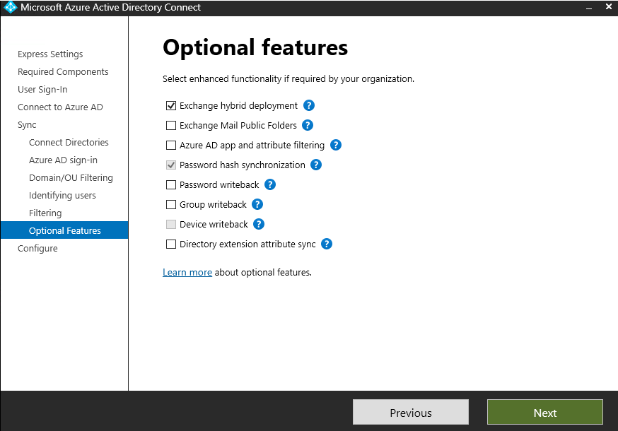

  - Custom SourceAnchor Hybrid Tenant:
For the second tenant, while configuring AAD connect, use custom configuration. On the following page, instead of default source anchor, choose customattribute1 as sourceanchor attribute. All other configurations would be default and please enable Exchange Hybrid deployment in this configuration as well.
Whatever attribute is chosen as source anchor, you need to ensure that whenever a new mailbox, group or contact is created the source anchor attribute is set and is unique in onprem AD or Exchange Server.

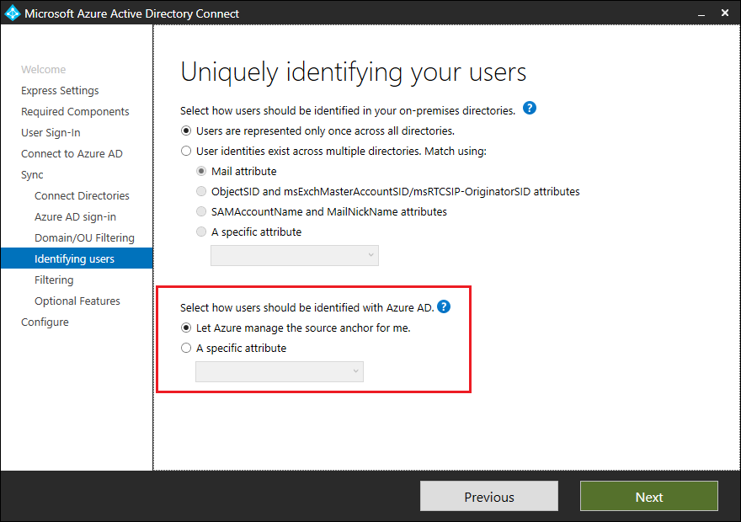

- Subsequently, use HCW to setup two Exchange Hybrid environments with above 2 tenants and their respective Exchange Server topologies.

Users, Groups required for Testing
Create following set of users:
- Onprem mailboxes, OP1, OP2.. etc who have onprem mailboxes.
- Create cloud mailboxes directly using new-remotemailbox and name them CU1, CU2 etc.
- Migrate some onprem mailboxes OP1, OP2, etc to cloud using new-moverequest or new-migrationbatch. Don’t migrate all mailboxes to cloud, keep some mailboxes onprem too for testing.
- Create few mailboxes directly in M365. These should not be created from Onprem server or AD. Name these COU1, COU2 etc.
- Create onprem distribution groups OPDG1, OPDG2 etc. and mail enabled security groups OPMESG1, OPMESG2 etc. and name them appropriately.
- Create cloud only distribution groups CDG1, CDG2 etc. and cloud only mail enable security groups CMESG1, CMESG2 etc.
Make more groups and users if required for testing specific scenarios.

Mailbox creation

On-prem Mailbox & Remate mailbox
- You can either use ECP of Exchange Server to create a remote mailbox or use powershell.
- For the custom sourceAnchor hybrid topology where customattribute1 is sourceanchor, ensure customattribute1 is uniquely set during or after new mailbox creation for all users and groups. For example, you can store value of alias in customattribute1.

Cloud Only mailbox
For the creation of cloud only mailboxes you need to use EXO powershell or M365 Exchange Admin Center of Tenant. Below are steps to create fully cloud mailboxes via EXO PowerShell.
- Open PowerShell and run Connect-ExchangeOnline
- To create user COU1, you can use following cmdlet in EXO PowerShell:
New-Mailbox -Name "COU1" -Password (ConvertTo-SecureString -String "" -AsPlainText -Force) -MicrosoftOnlineServicesID <upn>

Create hybrid Distribution Group in Exchange Server
You can create distribution group in EMS by executing following cmdlet.
New-DistributionGroup -Name "OPDG1" -Members cu1@contoso.com,cu2@contoso.com,op1@contoso.com,op2@contoso.com

Create cloud only Distribution Group in Exchange Online
New-DistributionGroup -Name "CDG1" -Members cu1@contoso.com,cu2@contoso.com,op1@contoso.com,op2@contoso.com,cou1@contoso.com

Create hybrid Mail enabled Security Group in Exchange Server
New-DistributionGroup -Name "OPMESG1" -Type "Security" -Members cu1@contoso.com,cu2@contoso.com,op1@contoso.com,op2@contoso.com

Create Mail enable Security Group in Exchange Online
New-DistributionGroup -Name "CMESG1" -Type "Security -Members cu1@contoso.com,cu2@contoso.com,op1@contoso.com,op2@contoso.com,cou1@contoso.com

Test Scenarios for Exchange Attribute SOA or LES
[Public Preview of Phase 1 completed: https://learn.microsoft.com/en-us/exchange/hybrid-deployment/enable-exchange-attributes-cloud-management]

Before enabling Exchange Attribute level SOA

Test Mail flow, Free busy and mailbox migration
Before starting the testing, ensure the following scenarios work/not work before enabling Exchange Attribute level SOA:
- Emails and calendar invites can be sent between on-prem mailboxes and remote mailboxes.
  - Check both send and receive of emails.

- Mail flow would not work between on-prem and cloud only mailboxes.

- Check free busy between on-prem and remote mailboxes

- Check free busy between on-prem and cloud only mailboxes. This shouldn’t work.

- Mailbox migration: Migrate few on-prem mailboxes to cloud and back to on-prem. This should also work.

Test editing of Exchange attributes in Exchange Server and Exchange Online for remote mailboxes or cloud migrated mailboxes
- Execute following cmdlets for one of the remote mailboxes in Exchange Server Management Shell:
Set-RemoteMailbox -Identity CU1 -CustomAttribute2 "abc"
Set-RemoteMailbox -Identity CU1 -HiddenFromAddressListsEnabled $true
Set-RemoteMailbox -Identity CU1 -Type Room
Set-RemoteMailbox -Identity CU1 -DisplayName “ChangedfromExchangeServer”
- Execute following cmdlets for groups in EMS
Add-DistributionGroupMember -Identity "OPMESG1" -Member "cu3@contoso.com"

- Do a delta sync in Entra Connect and wait for the changes to be reflected in EXO. [approx. 15 mins]
- Now, open Exchange Online PowerShell for the tenant and execute following cmdlet in EXO
Get-Mailbox CU1 | fl
Get-DistributionGroupMember –Identity " OPMESG1"
Results should verify that the above changes have synced to cloud.

- Now, try set-mailbox & group cmdlet in EXO powershell to edit same properties, and the below should not work.
Set-Mailbox CU1 -CustomAttribute2 "xyz"
Set-Mailbox CU1 -HiddenFromAddressListsEnabled $false
Set-Mailbox -Identity CU1 -Type Shared
Set-Mailbox -Identity CU1 -DisplayName “ChangedfromExchangeOnline”

Remove-DistributionGroupMember -Identity "OPMESG1" -Member "cu3@contoso.com"
Above cmdlets should not work and give error.

Enabling attribute level SOA without writeback for dir-synced mailbox or remote mailboxes [Tested Already]
For reference, we have the following users in our environment.
- Onprem mailboxes, OP1, OP2.. etc who have onprem mailboxes.
  - Migrate some onprem mailboxes OP1, OP2, etc to cloud using new-moverequest or new-migrationbatch. Don’t migrate all mailboxes to cloud, keep some mailboxes onprem too for testing.
- Create cloud mailboxes directly using new-remotemailbox and name them CU1, CU2 etc.
- Create a few mailboxes directly in M365. These mailboxes are cloud only mailboxes and these should not be created from Onprem server or AD. Name these COU1, COU2 etc.

- Enable attribute level SOA for various kinds of mailboxes and mailusers and record error and success message.
- Open Exchange Online Powershell and execute following cmdlet for a cloud migrated mailbox.
Set-Mailbox -Identity OP1 -IsExchangeCloudManaged true
[This will work if OP1 is migrated. If OPx is still on onprem, this cmdlet will fail. Record both cases.]
For successful execution, execute following cmdlet and verify if the SOA transfer happened properly. The result of below should be True.
Get-Mailbox OP1 | fl *IsExchangeCloudManaged

- Run Set-Mailbox Dirsynced cloud mailbox like CU1 with other parameter /attribute-
(flipping IsExchangeCloudManaged is exclusive operation)
Set-Mailbox -Identity CU1 -IsExchangeCloudManaged true -EmailAddresses @{add="abc@contoso.com"}

The above cmdlet should fail.

- Now, execute following cmdlet for a remote mailbox situated in cloud.
Set-Mailbox -Identity CU1 -IsExchangeCloudManaged true
[This will work.]
For successful execution, execute following cmdlet and verify if the SOA transfer happened properly. The result of below should be True.
Get-Mailbox CU1 | fl *IsExchangeCloudManaged

- Now, execute following cmdlets for a onprem mailbox OPx which is not migrated to cloud.
Set-Mailuser -Identity OP2 -IsExchangeCloudManaged true
[This will fail.]
Execute following cmdlet and verify SOA transfer didn’t happen. The result below should be False.
Get-Mailuser OP2 | fl *IsExchangeCloudManaged

- Now, execute following cmdlet for a cloud only mailbox situated in cloud.
Set-Mailbox -Identity COU1 -IsExchangeCloudManaged true
[This should fail]
Execute following cmdlet and verify that SOA transfer didn’t happen. The result below should be False.
Get-Mailbox COU1 | fl *IsExchangeCloudManaged

- Repeated enabling Isexchangecloudmanaged attribute should give error.
Execute following command for a remote mailbox more than twice:
Set-Mailbox -Identity CU1 -IsExchangeCloudManaged true
The above command should fail when attempted to run twice.

- Run Set-Mailbox Dirsynced cloud mailbox like CU1 with other parameter /attribute-
(flipping IsExchangeCloudManaged is exclusive operation)
Set-Mailbox -Identity CU1 -IsExchangeCloudManaged true -EmailAddresses @{add="abc@contoso.com"}
The above cmdlet should fail again.

- Modify Account attribute and Exchange attribute together from EXO on mailbox with IsExchangeCloudManaged = true
Set-Mailbox -Identity CU1 -DisplayName “abc” -CustomAttribute2 “xyz”

The above cmdlet should fail.
- Try set-mailbox without exchange admin permission in Tenant. The cmdlet should fail.

By the end of this exercise, we have CU1, OP1 mailboxes for which SOA of Exchange attributes are transferred to cloud.

Finding all the mailboxes for which attribute SOA is transferred to cloud
- To find all the dirsynced mailboxes for which attribute SOA is not enabled, execute following command.
Get-Mailbox -Filter "(IsDirSynced -eq 'True')" -ResultSize 10000 | ? {$_.IsExchangeCloudManaged -eq $false}

- To find all the dirsynced mailboxes for which attribute SOA is enabled, execute following command.
Get-Mailbox -Filter "(IsDirSynced -eq 'True')" -ResultSize 10000 | ? {$_.IsExchangeCloudManaged -eq $true}

Bulk cmdlet to transferring attribute SOA for all dirsynced mailboxes in the tenant
- Now enable attribute SOA for all dirsynced mailboxes in one go. [Try this cmdlet at the end , when all scenarios are tested.]
Get-Mailbox -Filter "(IsDirSynced -eq 'True')" -ResultSize 10000 | ? {$_.IsExchangeCloudManaged -eq $false} | Set-Mailbox -IsExchangeCloudManaged True

Detailed Test Scenarios of attribute SOA transferred mailboxes [Tested Already]

P0 Admin Scenarios to Test [Tested Already]
- Check basic exchange attribute editing in EXO. Execute following cmdlets in EXO Powershell for any mailbox for whom attribute SOA is transferred to cloud.
- Set-Mailbox CU1 -CustomAttribute2 "xyz"
- Set-Mailbox CU1 -HiddenFromAddressListsEnabled $false
- Set-Mailbox -Identity CU1 -Type Shared
All the above 3 cmdlets should work from EXO. Confirm the changed values via get-mailbox CU | fl
- Check some functionalties in EXO, that still won’t work due to Identity SOA still in OnPrem AD.
- Set-Mailbox -Identity CU1 -DisplayName “ChangedfromExchangeOnline”

- Remove-DistributionGroupMember -Identity "OPMESG1" -Member "cu3@contoso.com "
Above cmdlets should still not work and give error.

P0 User scenarios to Test [Tested Already??]
After enabling Exchange Attribute level SOA for a user CU1, check following end user scenarios:
- Emails and calendar invites can be sent between on-prem mailboxes, remote mailboxes and groups
  - Check both send and receive of emails.

- Mail flow would not work between on-prem mailboxes and cloud only mailboxes or groups.

- Check free busy between on-prem and remote mailboxes. This should work.

- Check free busy between on-prem and cloud only mailboxes. This shouldn’t work.

- Mailbox migration: Migrate few onprem mailboxes to cloud and back to onprem. This should also work.

Test editing of all Exchange properties for a attribute SOA transferred mailbox vs not SOA transferred remote mailbox [Tested Already]

Execute all the cmdlets mention below for an attribute SOA transferred mailbox and non-SOA transferred mailbox and note the difference.

Attribute Name | cmdlet | Error + Change is reflecting in Get-Mailbox cmdlet?  (Yes/No)
altRecipient | Set-Mailbox mohitm -ForwardingAddress "NestorW@M365x56888440.OnMicrosoft.com"
authOrig | Set-Mailbox mohitm -AcceptMessagesOnlyFrom "NestorW@M365x56888440.OnMicrosoft.com"
dLMemRejectPerms | Set-Mailbox mohitm -RejectMessagesFromDLMembers "SalesTeam@M365x56888440.OnMicrosoft.com"
dLMemSubmitPerms | Set-Mailbox mohitm -AcceptMessagesOnlyFromDLMembers "Tailspin@M365x56888440.OnMicrosoft.com"
extensionAttribute1 | Set-Mailbox mohitm -CustomAttribute1 "abc"
extensionAttribute10 | Set-Mailbox mohitm -CustomAttribute10 "abc"
extensionAttribute11 | Set-Mailbox mohitm -CustomAttribute11 "abc"
extensionAttribute12 | Set-Mailbox mohitm -CustomAttribute12 "abc"
extensionAttribute13 | Set-Mailbox mohitm -CustomAttribute13 "abc"
extensionAttribute14 | Set-Mailbox mohitm -CustomAttribute14 "abc"
extensionAttribute15 | Set-Mailbox mohitm -CustomAttribute15 "abc"
extensionAttribute2 | Set-Mailbox mohitm -CustomAttribute2 "abc"
extensionAttribute3 | Set-Mailbox mohitm -CustomAttribute3 "abc"
extensionAttribute4 | Set-Mailbox mohitm -CustomAttribute4 "abc"
extensionAttribute5 | Set-Mailbox mohitm -CustomAttribute5 "abc"
extensionAttribute6 | Set-Mailbox mohitm -CustomAttribute6 "abc"
extensionAttribute7 | Set-Mailbox mohitm -CustomAttribute7 "abc"
extensionAttribute8 | Set-Mailbox mohitm -CustomAttribute8 "abc"
extensionAttribute9 | Set-Mailbox mohitm -CustomAttribute9 "abc"
legacyExchangeDN | Cant be edited using Set-Mailbox
msExchArchiveGUID | GUIDs are not editable
msExchArchiveName | Set-Mailbox mohitm -ArchiveName "test"
msExchAssistantName | Set-User -Identity user@example.com -AssistantName "Assistant Name"
msExchAuditAdmin | Set-Mailbox mohitm -AuditAdmin Copy
msExchAuditDelegate | Set-Mailbox mohitm -AuditDelegate Update
msExchAuditDelegateAdmin
msExchAuditOwner | Set-Mailbox mohitm -AuditOwner Update
msExchBlockedSendersHash | Set-MailboxJunkEmailConfiguration -Identity user@example.com -BlockedSendersAndDomains @{Add="spam@example.com", "maliciousdomain.com"}
msExchBypassAudit | Set-MailboxAuditBypassAssociation -Identity "user@example.com" -AuditBypassEnabled $True
msExchDelegateListLink | Add-MailboxPermission -Identity "MailboxToBeAccessed@example.com" -User "DelegateUser@example.com" -AccessRights FullAccess -InheritanceType All
msExchELCExpirySuspensionEnd | Set-Mailbox -Identity "user@example.com" -RetentionHoldEnabled $true -RetentionHoldDuration 30  Get-Mailbox -Identity "user@example.com" | Select-Object Name, RetentionHoldEnabled, RetentionHoldDuration
msExchELCExpirySuspensionStart | Same as above
msExchELCMailboxFlags | Set-Mailbox -Identity "user@example.com" -RetentionPolicy "RetentionPolicyName"  Get-Mailbox -Identity "user@example.com" | Select-Object Name, RetentionPolicy
msExchEnableModeration | Set-Mailbox mohitm -ModerationEnabled $true
msExchExtensionCustomAttribute1 | Set-Mailbox mohitm -ExtensionCustomAttribute1 {"test"}
msExchExtensionCustomAttribute2 | Set-Mailbox mohitm -ExtensionCustomAttribute2 {"test"}
msExchExtensionCustomAttribute3 | Set-Mailbox mohitm -ExtensionCustomAttribute3 {"test"}
msExchExtensionCustomAttribute4 | Set-Mailbox mohitm -ExtensionCustomAttribute4 {"test"}
msExchExtensionCustomAttribute5 | Set-Mailbox mohitm -ExtensionCustomAttribute5 {"test"}
msExchHideFromAddressLists | set-Mailbox mohitm -HiddenFromAddressListsEnabled $true
msExchImmutableID | Set-Mailbox mohitm -ImmutableId "test"
msExchLitigationHoldDate | Set-Mailbox mohitm -LitigationHoldDate "2024"
msExchLitigationHoldOwner | Set-Mailbox mohitm -LitigationHoldOwner "test"
msExchMailboxAuditEnable | Set-Mailbox mohitm -AuditEnabled $False
msExchMailboxAuditLogAgeLimit | Set-Mailbox mohitm -AuditLogAgeLimit 95.00:00:00
msExchMailboxGuid | Cannot be edited
msExchModeratedByLink | Set-Mailbox mohitm -ModeratedBy "NestorW@M365x56888440.OnMicrosoft.com"
msExchModerationFlags | Set-Mailbox -Identity "user@example.com" -ModerationEnabled $true -ModeratedBy "Moderator1","Moderator2" -ByPassModerationFromSendersOrMembers "Sender1","Sender2" -SendModerationNotifications Internal  Get-Mailbox -Identity "user@example.com" | Select-Object Name, ModerationEnabled, ModeratedBy, ByPassModerationFromSendersOrMembers, SendModerationNotifications
msExchRecipientDisplayType | Same as below
msExchRecipientTypeDetails | Set-Mailbox mohitm -Type Regular
msExchRemoteRecipientType | NA
msExchRequireAuthToSendTo | Set-Mailbox mohitm -RequireSenderAuthenticationEnabled $true
msExchResourceCapacity | Set-Mailbox mohitm -ResourceCapacity 999
msExchRetentionComment | Set-Mailbox mohitm -RetentionComment "test"
msExchRetentionURL | Set-Mailbox mohitm -RetentionUrl "abc"
msExchSafeRecipientsHash | NA
msExchSafeSendersHash | Set-MailboxJunkEmailConfiguration -Identity user@example.com -TrustedSendersAndDomains @{Add="trusted@example.com", "safedomain.com"}
msExchSenderHintTranslations | Set-Mailbox -MailTipTranslations {en:"test"}
msExchUserHoldPolicies | Set-Mailbox -Identity "user@example.com" -LitigationHoldEnabled $true -LitigationHoldDuration 365
proxyAddresses | Set-Mailbox mohitm -EmailAddresses $r.EmailAddresses
publicDelegates
unauthOrig | Set-Mailbox mohitm -RejectMessagesFrom "JoniS@M365x56888440.OnMicrosoft.com"
userCertificate | Add the cmdlet <TBU>
userSMIMECertificates | Add the cmdlet

Edit sourceanchor attribute in cloud (only for custom source anchor attribute tenant) [Tested Already]
- Modify sourceanchor in onprem. Execute following command in Exchange Server Management shell.

Set-RemoteMailbox CU1 -CustomAttribute1 "abc"

Try to do delta sync, it should now give error in Entra Sync.

- Revert sourceanchor in onprem, error in entra sync would go away.

- Edit source anchor attribute from EXO on Dirsynced mailbox with IsExchangeCloudmanaged true

Set-Mailbox -Identity CU1 -CustomAttribute1 “abc”

This should work, there would be no error in Entra Sync.

Rollback Scenario [Tested Already]

Disabling isExchangecloudmanaged
- Execute following command in EXO powershell:
Set-Mailbox -Identity CU1 -IsExchangeCloudManaged false
- Now execute all the scenarios mentioned in 4.4 on CU1, the mailbox should behave like non-SOA transferred mailbox.

- Make change in the mailbox in onprem, the changes should also sync after running delta sync.
Set-RemoteMailbox CU1 -CustomAttribute1 "abc"

Repeated Disabling
Execute following command in EXO powershell again and again, it should give error.
Set-Mailbox -Identity CU1 -IsExchangeCloudManaged false

Create new user, assign license and make in cloud managed. [Tested Already]
- Create a user ADuser1 in onprem AD. Run delta sync to sync the user in EntraID. [DO NOT USE NEW MAILBOX]
- Now assign license to the user to enable the mailbox in cloud.
- Check the value of IsExchangeCloudManaged, it should be False.
Get-Mailbox ADuser1 | fl *IsExchangeCloudManaged

- Now execute scenarios mentioned in 4.4 for ADuser1, it should not work.
- Run following command to make the user cloud managed.
Set-Mailbox -Identity ADuser1 -IsExchangeCloudManaged true
- Now run all the scenario mentioned in 4.4 for ADuser 1, it should work.

Delete user from on-prem AD. [Tested Already]
Delete the user ADuser1 in onprem AD, the user should be deleted in EntraID as well after sync.

Org LES SOA flip [To be Tested] : ETA [Sep 15th]
This switch helps in setting tenant level flag which ensure all new dirsynced users have isexchangecloudmanaged set to true. So for testing we will enable the Tenant level flag, create new users and verify its cloud managed properties.

Enable the Tenant level switch in the organization
Set-OrganizationConfig -ExchangeAttributesCloudManagedbyDefault
To view if this property is set.
Get-OrganizationConfig | fl BlockExchangeProvisioningFromOnPremEnabled

Now create new users in On-Prem and verify
- Create a new remote mailbox via Exchange Server Management Shell and set its customattributes and emailaddress.
- Create a new user in On-Premises AD.
Run the Connect sync delta cycle.
In Exchange Online, powershell these users won’t be available via Get-mailbox. Verify.
Check M365 admin portal, find the above users and assign licenses to them to create their mailboxes.
In EXO powershell, check the value of isExchangecloudmanaged for these mailboxes. It should be True by default.

To roll back this property.
Set-OrganizationConfig -ExchangeAttributesServerManagedbyDefault
And check if the property is rolled back.
Get-OrganizationConfig | fl BlockExchangeProvisioningFromOnPremEnabled

Create new users again via RemoteMailbox and AD and check its isExchangeCloudmanaged properties. It would be False by default.

Phase 2: Test Scenarios for LES Recipient Management with WriteBack
<To be filled by Claude>

Test Scenarios for User and Group SOA

User and Groups required for testing
For User and Group SOA transfer, you need both Groups and users for testing. You can reuse set of users and groups or create new ones, if this is new topolofy:
- Onprem mailboxes, OP1, OP2.. etc who have onprem mailboxes.
- Create cloud mailboxes directly using new-remotemailbox and name them CU1, CU2 etc.
- Migrate some onprem mailboxes OP1, OP2, etc to cloud using new-moverequest or new-migrationbatch. Don’t migrate all mailboxes to cloud, keep some mailboxes onprem too for testing.
- Create few mailboxes directly in M365. These should not be created from Onprem server or AD. Name these COU1, COU2 etc.
- Create onprem distribution groups OPDG1, OPDG2 etc. and mail enabled security groups OPMESG1, OPMESG2 etc. and name them appropriately.
- Create cloud only distribution groups CDG1, CDG2 etc. and cloud only mail enable security groups CMESG1, CMESG2 etc.
Make more groups and users if required for testing specific scenarios.

Mailbox creation

On-prem Mailbox & Remate mailbox
- You can either use ECP of Exchange Server to create a remote mailbox or use powershell.
- For the custom sourceAnchor hybrid topology where customattribute1 is sourceanchor, ensure customattribute1 is uniquely set during or after new mailbox creation for all users and groups. For example, you can store value of alias in customattribute1.

Cloud Only mailbox
For the creation of cloud only mailboxes you need to use EXO powershell or M365 Exchange Admin Center of Tenant. Below are steps to create fully cloud mailboxes via EXO PowerShell.
- Open PowerShell and run Connect-ExchangeOnline
- To create user COU1, you can use following cmdlet in EXO PowerShell:
New-Mailbox -Name "COU1" -Password (ConvertTo-SecureString -String "" -AsPlainText -Force) -MicrosoftOnlineServicesID <upn>

Create hybrid Distribution Group in Exchange Server
You can create distribution group in EMS by executing following cmdlet.
New-DistributionGroup -Name "OPDG1" -Members cu1@contoso.com,cu2@contoso.com,op1@contoso.com,op2@contoso.com

Create cloud only Distribution Group in Exchange Online
New-DistributionGroup -Name "CDG1" -Members cu1@contoso.com,cu2@contoso.com,op1@contoso.com,op2@contoso.com,cou1@contoso.com

Create hybrid Mail enabled Security Group in Exchange Server
New-DistributionGroup -Name "OPMESG1" -Type "Security" -Members cu1@contoso.com,cu2@contoso.com,op1@contoso.com,op2@contoso.com

Create Mail enable Security Group in Exchange Online
New-DistributionGroup -Name "CMESG1" -Type "Security -Members cu1@contoso.com,cu2@contoso.com,op1@contoso.com,op2@contoso.com,cou1@contoso.com

Before enabling User and Group SOA

Test Mail flow and Free busy
(Skip if checked this scenario already for Attribute level SOA transfer)
Before starting the testing, ensure the following scenarios work/not work before enabling Exchange Attribute level SOA:
- Emails and calendar invites can be sent between on-prem mailboxes, remote mailboxes and groups
  - Check both send and receive of emails.

- Mail flow would not work between on-prem mailboxes and cloud only mailboxes or groups.

- Check free busy between on-prem and remote mailboxes. This should work.

- Check free busy between on-prem and cloud only mailboxes. This shouldn’t work.

- Mailbox migration: Migrate few onprem mailboxes to cloud and back to onprem. This should also work.

Edit attributes in Exchange Server and Exchange Online for remote mailboxes or cloud migrated mailboxes

- Execute following cmdlets for one of the remote mailboxes in Exchange Server Management Shell:
Set-RemoteMailbox CU1 -CustomAttribute1 "abc"
Set-RemoteMailbox CU1 -HiddenFromAddressListsEnabled $true
Set-RemoteMailbox -Identity CU1 -Type Room
Set-RemoteMailbox -Identity CU1 -DisplayName “ChangedfromExchangeServer”
Execute following cmdlets for groups in EMS
Add-DistributionGroupMember -Identity "OPMESG1" -Member cu3@contoso.com
Add-DistributionGroupMember -Identity "OPDG1" -Member "cu3@contoso.com"

- Do a delta sync in Entra Connect and wait for the changes to be reflected in EXO. [approx. 15 mins]
- Now, open Exchange Online PowerShell for the tenant and execute following cmdlet in EXO
Get-Mailbox CU1 | fl
Get-DistributionGroupMember -Identity " OPMESG1"
Results should verify that the above changes have synced to cloud.

- Now, try set-mailbox & group cmdlet in EXO powershell to edit same properties, and the below should not work.
Set-Mailbox CU1 -CustomAttribute2 "xyz"
Set-Mailbox CU1 -HiddenFromAddressListsEnabled $false
Set-Mailbox -Identity CU1 -Type Shared
Set-Mailbox -Identity CU1 -DisplayName “ChangedfromExchangeOnline”

Remove-DistributionGroupMember -Identity "OPMESG1" -Member cu3@contoso.com
Remove-DistributionGroupMember -Identity "OPDG1" -Member "cu3@contoso.com"

Above cmdlets should not work and give error.

Enabling User SOA and Group SOA
<To be shared by AAD team>
By the end of this exercise, we should have CU1, OP1, OPMESG1, OPDG1 mailboxes and groups for which object SOA is transferred to cloud.

Detailed Test Scenarios for User SOA and Group SOA

P0 Admin Scenarios to Test
- Check basic exchange attribute editing in EXO. Execute following cmdlets in EXO Powershell for any mailbox for whom attribute SOA is transferred to cloud.
- Set-Mailbox CU1 -CustomAttribute2 "xyz"
- Set-Mailbox CU1 -HiddenFromAddressListsEnabled $false
- Set-Mailbox -Identity CU1 -Type Shared
- Set-Mailbox -Identity CU1 -DisplayName “ChangedfromExchangeOnline”
- Remove-DistributionGroupMember -Identity "OPMESG1" -Member cu3@contoso.com
- Remove-DistributionGroupMember -Identity "OPDG1" -Member "cu3@contoso.com"
All the above cmdlets should work from EXO. Confirm the changed values via
get-mailbox CU | fl
get-distributiongroupmember OPMESG1 |fl
get-distributiongroupmember OPDG1 | fl

P0 User scenarios to Test
After enabling Exchange Attribute level SOA for a user CU1, check following end user scenarios:
- Emails and calendar invites can be sent between on-prem mailboxes, remote mailboxes and groups
  - Check both send and receive of emails.

- Mail flow would not work between on-prem mailboxes and cloud only mailboxes or groups.

- Check free busy between on-prem and remote mailboxes. This should work.

- Check free busy between on-prem and cloud only mailboxes. This shouldn’t work.

- Mailbox migration: Migrate few onprem mailboxes to cloud and back to onprem. This should also work.

Test cloud management of Object SOA transferred users and groups
Test following cmdlets for an attribute SOA transferred mailbox.

Attribute Name | cmdlet | Error + Change is reflecting in Get-Mailbox cmdlet?  (Yes/No)
altRecipient | Set-Mailbox mohitm -ForwardingAddress "NestorW@M365x56888440.OnMicrosoft.com"
authOrig | Set-Mailbox mohitm -AcceptMessagesOnlyFrom "NestorW@M365x56888440.OnMicrosoft.com"
dLMemRejectPerms | Set-Mailbox mohitm -RejectMessagesFromDLMembers "SalesTeam@M365x56888440.OnMicrosoft.com"
dLMemSubmitPerms | Set-Mailbox mohitm -AcceptMessagesOnlyFromDLMembers "Tailspin@M365x56888440.OnMicrosoft.com"
extensionAttribute1 | Set-Mailbox mohitm -CustomAttribute1 "abc"
extensionAttribute10 | Set-Mailbox mohitm -CustomAttribute10 "abc"
extensionAttribute11 | Set-Mailbox mohitm -CustomAttribute11 "abc"
extensionAttribute12 | Set-Mailbox mohitm -CustomAttribute12 "abc"
extensionAttribute13 | Set-Mailbox mohitm -CustomAttribute13 "abc"
extensionAttribute14 | Set-Mailbox mohitm -CustomAttribute14 "abc"
extensionAttribute15 | Set-Mailbox mohitm -CustomAttribute15 "abc"
extensionAttribute2 | Set-Mailbox mohitm -CustomAttribute2 "abc"
extensionAttribute3 | Set-Mailbox mohitm -CustomAttribute3 "abc"
extensionAttribute4 | Set-Mailbox mohitm -CustomAttribute4 "abc"
extensionAttribute5 | Set-Mailbox mohitm -CustomAttribute5 "abc"
extensionAttribute6 | Set-Mailbox mohitm -CustomAttribute6 "abc"
extensionAttribute7 | Set-Mailbox mohitm -CustomAttribute7 "abc"
extensionAttribute8 | Set-Mailbox mohitm -CustomAttribute8 "abc"
extensionAttribute9 | Set-Mailbox mohitm -CustomAttribute9 "abc"
legacyExchangeDN | Cant be edited using Set-Mailbox
msExchArchiveGUID | GUIDs are not editable
msExchArchiveName | Set-Mailbox mohitm -ArchiveName "test"
msExchAssistantName | Set-User -Identity user@example.com -AssistantName "Assistant Name"
msExchAuditAdmin | Set-Mailbox mohitm -AuditAdmin Copy
msExchAuditDelegate | Set-Mailbox mohitm -AuditDelegate Update
msExchAuditDelegateAdmin
msExchAuditOwner | Set-Mailbox mohitm -AuditOwner Update
msExchBlockedSendersHash | Set-MailboxJunkEmailConfiguration -Identity user@example.com -BlockedSendersAndDomains @{Add="spam@example.com", "maliciousdomain.com"}
msExchBypassAudit | Set-MailboxAuditBypassAssociation -Identity "user@example.com" -AuditBypassEnabled $True
msExchDelegateListLink | Add-MailboxPermission -Identity "MailboxToBeAccessed@example.com" -User "DelegateUser@example.com" -AccessRights FullAccess -InheritanceType All
msExchELCExpirySuspensionEnd | Set-Mailbox -Identity "user@example.com" -RetentionHoldEnabled $true -RetentionHoldDuration 30  Get-Mailbox -Identity "user@example.com" | Select-Object Name, RetentionHoldEnabled, RetentionHoldDuration
msExchELCExpirySuspensionStart | Same as above
msExchELCMailboxFlags | Set-Mailbox -Identity "user@example.com" -RetentionPolicy "RetentionPolicyName"  Get-Mailbox -Identity "user@example.com" | Select-Object Name, RetentionPolicy
msExchEnableModeration | Set-Mailbox mohitm -ModerationEnabled $true
msExchExtensionCustomAttribute1 | Set-Mailbox mohitm -ExtensionCustomAttribute1 {"test"}
msExchExtensionCustomAttribute2 | Set-Mailbox mohitm -ExtensionCustomAttribute2 {"test"}
msExchExtensionCustomAttribute3 | Set-Mailbox mohitm -ExtensionCustomAttribute3 {"test"}
msExchExtensionCustomAttribute4 | Set-Mailbox mohitm -ExtensionCustomAttribute4 {"test"}
msExchExtensionCustomAttribute5 | Set-Mailbox mohitm -ExtensionCustomAttribute5 {"test"}
msExchHideFromAddressLists | set-Mailbox mohitm -HiddenFromAddressListsEnabled $true
msExchImmutableID | Set-Mailbox mohitm -ImmutableId "test"
msExchLitigationHoldDate | Set-Mailbox mohitm -LitigationHoldDate "2024"
msExchLitigationHoldOwner | Set-Mailbox mohitm -LitigationHoldOwner "test"
msExchMailboxAuditEnable | Set-Mailbox mohitm -AuditEnabled $False
msExchMailboxAuditLogAgeLimit | Set-Mailbox mohitm -AuditLogAgeLimit 95.00:00:00
msExchMailboxGuid | Cannot be edited
msExchModeratedByLink | Set-Mailbox mohitm -ModeratedBy "NestorW@M365x56888440.OnMicrosoft.com"
msExchModerationFlags | Set-Mailbox -Identity "user@example.com" -ModerationEnabled $true -ModeratedBy "Moderator1","Moderator2" -ByPassModerationFromSendersOrMembers "Sender1","Sender2" -SendModerationNotifications Internal  Get-Mailbox -Identity "user@example.com" | Select-Object Name, ModerationEnabled, ModeratedBy, ByPassModerationFromSendersOrMembers, SendModerationNotifications
msExchRecipientDisplayType | Same as below
msExchRecipientTypeDetails | Set-Mailbox mohitm -Type Regular
msExchRemoteRecipientType | NA
msExchRequireAuthToSendTo | Set-Mailbox mohitm -RequireSenderAuthenticationEnabled $true
msExchResourceCapacity | Set-Mailbox mohitm -ResourceCapacity 999
msExchResourceDisplay | Set-ResourceConfig -ResourcePropertySchema @{Add="Room/Presentation", "Room/Video", "Room/HDMI", "Room/Capacity"}  Set-Mailbox RoomMailbox -ResourceCustom "Presentation", "Video", "HDMI", "Capacity"
msExchResourceMetaData | NA
msExchResourceSearchProperties | NA
msExchRetentionComment | Set-Mailbox mohitm -RetentionComment "test"
msExchRetentionURL | Set-Mailbox mohitm -RetentionUrl "abc"
msExchSafeRecipientsHash | NA
msExchSafeSendersHash | Set-MailboxJunkEmailConfiguration -Identity user@example.com -TrustedSendersAndDomains @{Add="trusted@example.com", "safedomain.com"}
msExchSenderHintTranslations | Set-Mailbox -MailTipTranslations {en:"test"}
msExchTeamMailboxExpiration | NA
msExchTeamMailboxOwners
msExchTeamMailboxSharePointUrl
msExchUserHoldPolicies | Set-Mailbox -Identity "user@example.com" -LitigationHoldEnabled $true -LitigationHoldDuration 365
proxyAddresses | Set-Mailbox mohitm -EmailAddresses $r.EmailAddresses
publicDelegates
targetAddress | Not needed for mailbox, used for mailuser which is out of scope
thumbnailphoto
unauthOrig | Set-Mailbox mohitm -RejectMessagesFrom "JoniS@M365x56888440.OnMicrosoft.com"
userCertificate | Add the cmdlet <TBU>
userSMIMECertificates | Add the cmdlet

Rollback Scenario
How? To be shared by AAD team
Now the objects

Testing timeline

- LES Phase 1 [Closure by March End?]
  - P0: Mailbox level Attribute SOA transfer
  - P1: Tenant level Attribute SOA transfer
- User and Group SOA transfer [Closure by March End?]
- LES Phase 2
  - Enable Writeback

Steps to Report Bugs
Follow the steps given below-
- Go to link - New Bug 1*
- Add Title prefixed with Test case ID
- Select AreaPath - O365 Core\EXO Manageability
- Add Tag – “LES_Testing”
- Iteration – “O365 Core”
- Add corresponding UserStory as Parent work item for the Bug
- Assign it to “Nithya R” (ni@microsoft.com)

References
PM Spec- Last Exchange Server - cloud management of dirsynced mailboxes(final spec).docx (sharepoint.com)
Dev spec - https://microsoft-my.sharepoint-df.com/:w:/r/personal/diganr_microsoft_com/_layouts/15/doc2.aspx?sourcedoc=%7B9F21ECE7-8C0C-48AF-9273-A2B7B61B820B%7D&file=LES%20Recipient%20Mgmt%20Exchange.docx&wdOrigin=TEAMS-MAGLEV.p2p_ns.rwc&action=default&mobileredirect=true&share=IQHn7CGfDIyvSJJzore2G4ILASCkTxeY8NtzsB01Vj3OXqg&isSPOFile=1&clickparams=eyJBcHBOYW1lIjoiVGVhbXMtRGVza3RvcCIsIkFwcFZlcnNpb24iOiI0OS8yNDA4MTcwMDQwNyIsIkhhc0ZlZGVyYXRlZFVzZXIiOmZhbHNlfQ%3D%3D
Spec from AAD - Deprecating Last Exchange Server - AAD Design.docx (sharepoint-df.com)

Change History
Date | Version | Details of Changes
2024-12-12 | V1.0 | Initial draft for testing Guideline
2024-12-24 | V1.1 | Resolved comments based on Initial review

